EGYPT – THE GIFT OF THE NILE

Egypt is a country that is extremely mysterious and an architect’s delight. To this day it draws visitors who come here to see the awe inspiring pyramids which to this day remain a mystery. This country is not like the other “Foreign countries” and hence cannot expect to find the same trappings here.

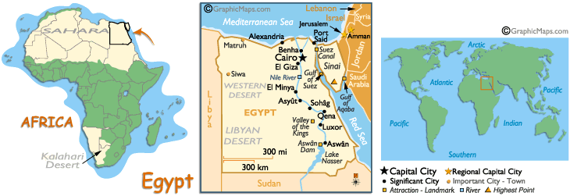

VISA : The visa is to be obtained prior to arrival in the country.

HOW TO GET THERE:
INTERNATIONAL AIRPORT: Cairo is the only International Airport here.

FLIGHTS INTO CAIRO:
Direct Flight is Egypt Air (MS) ex BOM flying thrice a week – Tues, Thurs, Sun - 6hrs 45 mins

Sectors | Timings
BOM CAI  Tues Thurs Sun | Dep 0410  Arr 0745
CAI BOM  Mon Wed Sat | Dep 0430  Arr 1140

Emirates(EK) flies into Cairo via Dubai ex Mumbai, Delhi, Kolkata, Chennai, Hyderabad, Ahmedabad, Bangalore

Imp Note:
Please note that a client can spend a maximum of 2 hours in Abu Simbel as per the Law passed by the Govt. of Egypt.
Hence, please make sure any connecting flight from Abu Simbel to Aswan is booked within 2 hours. If a later flight is booked Egyptian Air will automatically cancel the booking.

CURRENCY:
The basic unit of money is the Egyptian pound (L.E), which is divided into 100 Piasters. You can bring to Egypt any reasonable amount of traveler’s checks and cash. The exchange rates are subject to change. You will have no need to use Egyptian money before your arrival at the hotel. You can exchange currency in the hotel during 24 hours a day. When you exchange money keep your receipts and keep your customs declaration (Form D) in order to change Egyptian currency back into dollars when leaving the country.

GETTING AROUND:
Egypt has two national carriers for internal flights, Egyptair (MS) and Air Sinai (4D)

Public Transport

By Air: Egypt air flies daily from Cairo to Alexandria, Luxor, Aswan, Abu Simbel, and Hurghada and twice a week to Kharga Oasis.
Air Sinai flies from Cairo to Hurghada, Al Arish, Taba, Sharm el Shaikh.

Bus: Air- conditioned buses link most parts of Egypt to Cairo and Alexandria.
Tram: Cairo also has tram systems and Heliopolis is served by six tram lines
Metro: Both Alexandria and Cairo have metro systems that run through at least part of the city. Trains run every few minutes from early morning (5:30 a.m.) to midnight and fares are inexpensive, usually under a pound to the farthest destination.
Taxis: Metered taxis are available. All taxis have orange license plates and are identified by a number on the driver's license and identify number attached to the dashboard. Sharing a taxi is not unusual. For the tourist, it is more expensive but easier to get a taxi from a hotel where they line up and where you can fix the price beforehand.

Trains:
First-class train services connect Cairo with Alexandria, Luxor and Aswan
You can travel between Cairo, Luxor and Aswan on 4 different types of train:
- Overnight deluxe sleeper train (1- & 2-bed sleepers & lounge car, recommended)
- Overnight air-conditioned express trains (with seats)
- Daytime air-conditioned express trains (recommended)

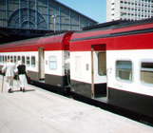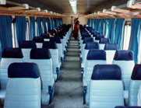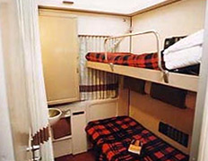

Sleeper Train: [Cairo/Aswan Or Luxor/Cairo On Half Board]
Per Person in a Double Cabin per way - 68 USD
For Single per way – 91 USD

It has many cars and each car has 10 cabins i.e. 20 beds in total.
There are 2 bathrooms outside the cabins.
Each cabin has central a/c and music.
In the middle of the train there is a club car (bar wagon) where one can enjoy drinks - alcoholic or non alcoholic.
Breakfast and hot dinner is included.

Timings:
Daily train Cairo - Luxor 0800 pm – 0505 am
Luxor - Aswan 0515 am – 0815 am

Daly train Aswan - Luxor 0630 pm – 0930 pm
Luxor - Cairo 0940 pm - 0645 am

Distances between Egyptian cities:

Cities | Kms | By Air | By Train | By Bus | By  Private Car
Cairo - Alexandria | 210 | 45 mins | 2.30 hrs | 3hrs | 3hrs
Cairo – Luxor | 680 | 1 hr | 09 hrs | NA | NA
Cairo – Aswan | 930 | 1.25hrs | 12 hrs | NA | NA
Luxor -Aswan | 240 | 45 mins | 3.5 hrs | NA | NA
Cairo - Baharia Oasis | 400 | NA | NA | NA | 4hrs
Cairo – Hurghada | 480 | 1 hr | NA | 6hrs | 6hrs
Luxor -Hurghada | 230 | NA | NA | 3hrs | 3hrs
Cairo-SharmEl Shaikh | 460 | 1hr | NA | 6hrs | 6hrs

BUSINESS:
Friday is the weekly holiday; most business is closed at least in the morning. The official hours for banks and commerce are from 10: 00 am to 6: 00 pm. Many stores, especially in the tourist areas and hotels, are open all day and during evenings.

CLIMATE:
Egypt's climate is hot and dry most of the year. During the winter months - December, January and February - average daily temperatures stay up around 20°C on the Mediterranean coast and a pleasant 26°C in Aswan. Maximum temperatures get to 31°C and 50°C respectively. Winter nights only get down to 8°C. Alexandria receives the most rain. While Aswan is almost bone-dry with just 2 mm annually. Between March and April the khamsin blows in from the Western Desert.
The best months to visit this country are starting Oct until April. The hottest month is Aug and it is rather hot starting from June onwards.

CLOTHING:
The word is cotton, and not even heavy blends with synthetics will do. Regular jeans are also worn. Wear closed, comfortable shoes for tours (sneakers, tennis shoes), but you might wear any kind of sandals, etc around the hotel area and in town. A very light hat and sunglasses are necessary for protection against the hot sun. Sun Block and Sun tan lotion is also a must.
It Is important to remember that Egypt is an Islamic country, leave your shorts at home. Ladies should also choose dresses and blouses with some kind of sleeves and no “generous” openings around the neck. Improper clothing is perceived as a cultural insult. However, bring your swimsuit and cover – up to get to the swimming pool, as you will have to pass through the hotel. For the dinner hour it’s usually a little more dressy than on the road, so, do not dress in tee-shirts and jogging outfits for dinner. The “galabeya” is the traditional Egyptian dress and is akin to a loose kaftan. It’s easy to wear and is used during one of the themed evenings that you may have a chance of attending.

TIME:
Egypt is 2 hrs 30 mins behind us.

ELECTRICITY:
For your personal appliances you need an electrical converter and the European round – pronged plugs. The voltage is 220 v.

DAILING CODE:
00 20

TIPS:
“Baksheesh” (tips) is the first Arabic word you have to learn. As salaries are very low in Egypt,
“Baksheesh” is a way of life. For your stay in a hotel room, leave one pound minimum a day. Tips must be given to the guides and the driver too. The little Egyptian children love stationary. Hence it would be handy for you to carry from here some pencils and ball point pens that you could give away at the various monuments during your sightseeing tours. However giving money to the little children is a complete NO.

LANGUAGE:
Arabic is the national language, though in the hotels and your guides are well versed in English.

INFORMATIVE WEBSITES:
www.egypt.travel or www.lonelyplanet.com under Egypt.

IMPORTANT POINTS REGARDING THE HOTELS:
In Egypt there is no governing body that rates the Hotels. The 3 and the 4 star hotels are not worth recommending as they are very small and are of generally very poor standards. The 5* hotels that are part of a chain e.g. the Hyatt / Hilton / Four seasons etc are recommended as one can expect the standard here. The price difference between the 4 and the 5 star hotels is not that great, hence can be easily opted for.

REGISTRATION IN HOTELS:
When arriving in the hotels your passports may be requested for 24 hours. They will be returned promptly to you later. This registration is for your security only. The Egyptians treat their tourists as most precious, the hotels are well guarded (discretely), you will find Egypt one of the safest countries to travel to. Before the arrival at a new destination keep your passport handy, at least in your carry – on luggage, never in the suitcase or check – in luggage.

IMPORTANT POINTS REGARDING THE CRUISES:
The moment one talks about a cruise here, it is very important that one does not equate it to one of the luxury cruises like the Star or the Royal Caribbean etc that one is so used to selling or sailing on. Pls note that the cruise here is akin to a barge and is used to ferry a person from point A to point B. Cruises operate between Luxor and Aswan or vice versa.
Here too, like the hotels it is recommended to opt only for the 5 star cruises. The best cruise operating is the Sonesta Moon Goddess. Other 5 star cruises are Anni, Aton, Carnival, Florence, Nile Delta, Solaris I, Domina, Crocodile.
One can opt for either a 4 night cruise plying every Sat / Mon or Thu Ex Luxor or the 4 night cruise plying every Sat or Tue Ex Aswan.
Or the 3 nights cruise plying every Mon / Wed or Friday Ex Aswan.
There is no provision of pre blocking cabins on board in advance. The same are allotted on a first come first serve basis.
There is also no concept of inside cabins here. All the cabins have windows facing the river. The check in time is normally before lunch at 1200 hrs.
During lunch and dinner time, all tables are numbered and each family/cabin is allotted one particular table number that is yours till the end of the cruise. Indian Food is not available on board, however vegetarian food can be made available.
The pool on the deck is small and varies from cruise to cruise. Invariably one of the evenings hosts a themed night called the “galabeya” night where all the guests must come dressed in the traditional galabeya.
The cruise sets sail during the nights and docks during the day and hence all the sightseeing is done during the day post breakfast so that you are back by lunchtime and can relax for the rest of the day on board.

- Ex Luxor - 04 Nights Cruise - Sat/ Mon/ Thu
- Ex Aswan - 04 Nights Cruise - Sat/ Tue
- Ex Aswan - 03 Nights Cruise - Mon/ Wed/ Fri

Kindly note that embarkation time usually be before lunch which is around noon time .
Once clients arrive Luxor [if the cruise will start from Luxor] they will make the tour then embark the cruise if the cabins not ready & once they arrive Aswan [if the cruise will start from Aswan] they will make the tour first on there way to the cruise as the sight places close to the airport & it's better to do it first in order not to drive back again for about 30 KM

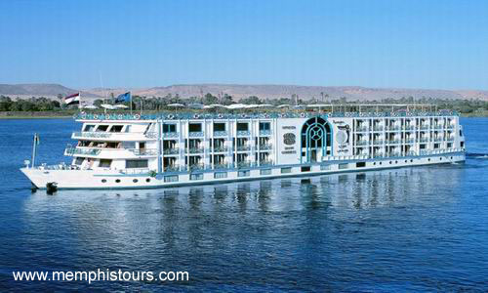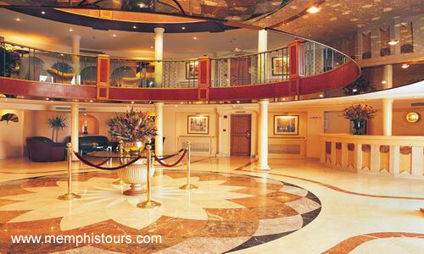

CITIES:

CAIRO

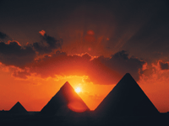

This is the capital city and abounds with action. The main gateway city and is also the city that houses the great Pyramids and the Egyptian Museum. The city has 2 distinct areas, the downtown area and the Giza area. The Downtown area has several hotels that overlook the Nile River and the Giza area is where the pyramids are.
Cairo is a city that does not sleep. One can expect to find traffic jams normally at 3 am in the mornings!!

Hotels in Cairo:
It’s best to stay in the Giza area upon arrival so that you are closer to the pyramids. The only hotel that is bang opposite the pyramids is the Mena Oberoi and this hotel has 2 wings – the Pyramid facing and the Garden facing rooms. Others that are highly recommended are the Le Meridien Pyramids that also has a side view of the pyramids, the Movenpick Pyramids ( more resort style and is a 4*), the Sheraton Pyramids (this is the farthest on the strip leading up to the pyramids). There is a Four Seasons here too which is a little far from the pyramids though.
After the first stay in Cairo one normally would go off for the cruise and upon return would spend another night or two in Cairo again. On the return stay, it is recommended to stay in the Downtown area. One can opt for the Nile Hilton or the Hyatt etc and if required can also ask for the Nile view room which comes at a supplement charge.

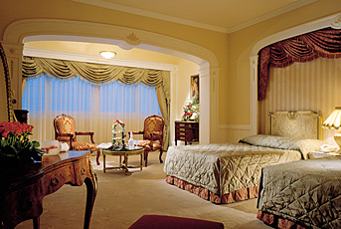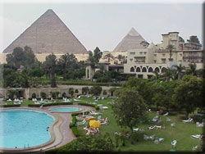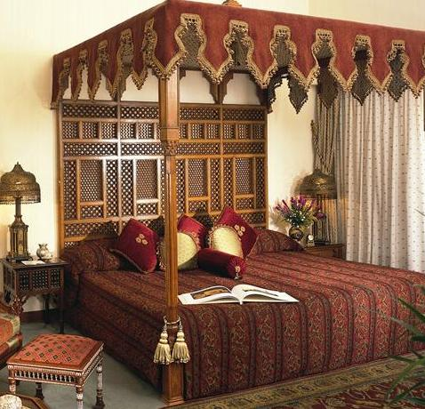

MUST SEES:

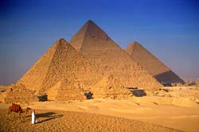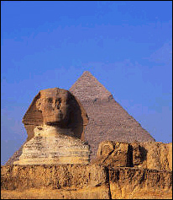

Great Pyramids:
Located in the Giza area, this is truly awe inspiring experience as how these structures were built is still a mystery! Before you stop at the main pyramids you are taken to the 1st pyramid that was built – the Step Pyramid. Following this the next stop is the 3 pyramids which are located next to each other. One can opt to visit the inside of the great pyramid (this is not included in the cost, since it could get very suffocating once inside, moreover one needs to crawl on all fours to get through the thin passage). There are no mummies here, since they have all been moved to the Egyptian Museum.
Just next to the pyramids is the great Sphinx. This visit terminates around lunch time. There is a Pizza Hut near the pyramids where you can ask the guide to take you for a bite.
Open daily 08h00-16h00.
Additional tickets required for the Great Pyramid, Chephren's Pyramid and the Third Pyramid. The newly opened Tomb of Mend Skegr Ka (the daughter of King Cheops), and the Tomb of Ayassen (noted for its reliefs of daily life in ancient Egypt) are both free to enter. Note that only 300 tickets per day are issued for the Great Pyramid on a first come, first served basis.

Egyptian Museum:
This is the most famous icon in Cairo next to the Pyramids. Considering the number of artifacts it holds, one would need a week or more to ensure that all the exhibits have been looked at. However in half a day, your guide will tell you where to go and which are the ones you should definitely take a look at. There are 2 areas in the Museum – The Mummies chamber and the Tutankhamun’s treasures that are stored separately and in order to visit the same, there is an extra charge payable directly inside. This is not included in the entry ticket.
Open: daily 09h00-16h45 (Ramadan 09h00-15h00)

Cairo city tour with Pharonic Village:
Visit the Cairo Tower the highest building in all over Egypt (187 meters high) and it gives the visitor a chance to see the whole of Cairo and has a revolving restaurant, then continue to the Pharaonic village which covers 32 acres, located in Jacop's Island in Giza, view of all activities practised by ancient egyptians with the style of the life in the ancient time. With some museums like: Islamic, Coptic, mummification museum and a copy of the tomb of King Tutankhamun.

Cairo Tower:
Opened in 1962 and an impressive 87m high, the Cairo Tower is one of the highest buildings in Africa. Once the tallest concrete structure in the world the tower .
The tower is now one of Cairo's major tourist draws. The first of the top two storeys is a pricey revolving café and restaurant but the main attraction lies above. At the top of the building is an observation platform where visitors can enjoy one of the most spectacular views in Egypt, out over the city all the way to the Pyramids and the Nile Delta. The view is particularly inspiring at sunset when the buildings of the city are thrown into shadow below.
Situated at Zamalek (Gezira) Island. Open: daily 10h00-19h30.

Papyrus and the Perfume / Jewellery Shops:
Egypt is ever famous for the handmade paper that was made here. It’s called Papyrus and what is now a must buy here are the intricate paintings that one makes on these hand made papers. One can actually see the entire process of making paper.
A visit to the perfume house gives us insight into how the famous Calvin Klein, Poison, Issey Miyaki, Davidoff Cool Water etc are made. The seed comes from here. One can buy small bottles of the concentrate at 1/4th the price of the branded bottles! These are all original.
Finally the jewellery shops sell a variety of precious and semi precious stones which are worth buying.

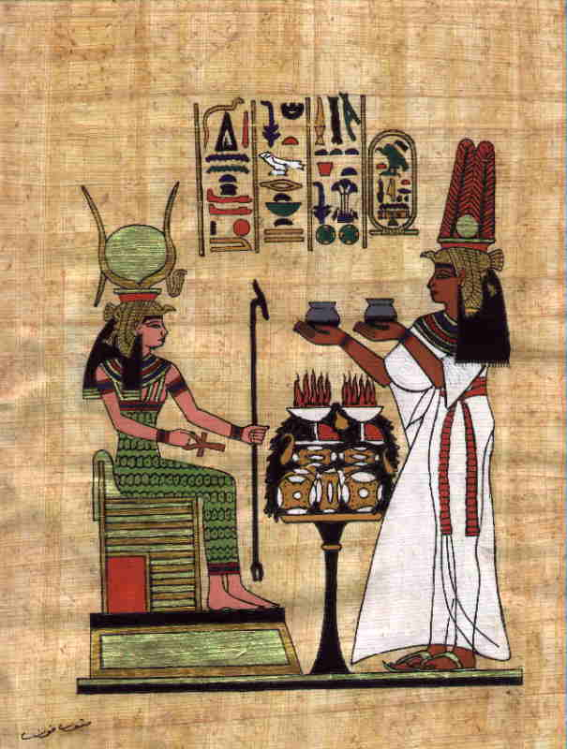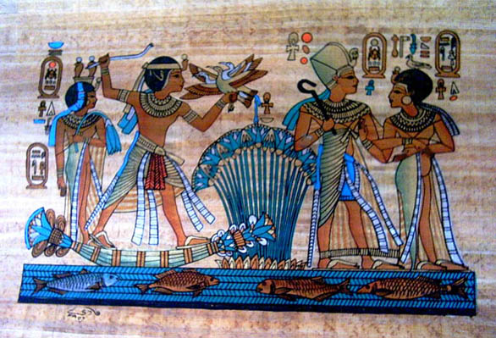

Dinner Nile Cruise:
An Ideal way to spend the evening. Cruise On The River Nile For 02 Hours with open buffet dinner, belly dancing, eastern band, western band, folkloric performers on an open air deck

Nile & Golden Pharaohs
It’s Trip at 07.45 PM & 08.15 PM
It Costs 40 $ pp

Nile Crystal
It’s Trip at 08.00 PM & 08.30 PM
It Costs 35 $ pp

Sound and Light Show at the Pyramids:
The show happens at the pyramids area and lasts around 40 mins. It commences around 1900 hours.
It’s a historical show, just in front of the pyramids of Giza and the Sphinx together; it shows you how they had built the pyramids & the life of every king on these pyramids.

Sound & Light Show is Every Day except Sunday
** First Show On: Every Saturday, Monday, Tuesday, Wednesday and Friday
First Show Time: - 18.30 - 19.15 (Winter Timing) & 20.30 - 21.15 (Summer Timing)
** Second Show On: Every Thursday
Second Show Time: - 19.30 - 20.15 (Winter Timing) & 21.30 - 22.15 (Summer Timing)

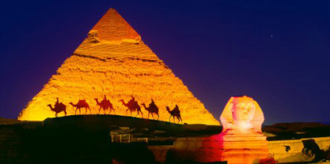

Saqqara:
Saqqara was the necropolis of Egyptian nobility, and covers some seven square km of desert. Among the highlights are the Tomb of Maya, only discovered in 1986, and the Step Pyramid, the funerary complex of King Zhoser, dating from the 27th century BC and the inspiration of the great pyramids that were to follow.
The Serapeum is also located here, a vast subterranean passage, which held the mummified corpses of the sacred Apis bulls, regarded as manifestations of, father of the Gods, Ptah's soul. Among the private tombs, those of the nobles of the 5th and 6th dynasties are noteworthy for their well-preserved painted scenes of daily life.
Open: daily 08h00-16h00. The Step Pyramid is only viewable from the exterior and attractions are periodically closed to the public.

LUXOR

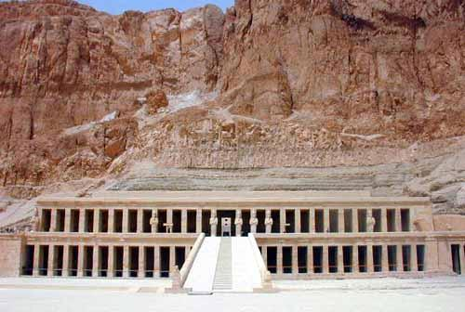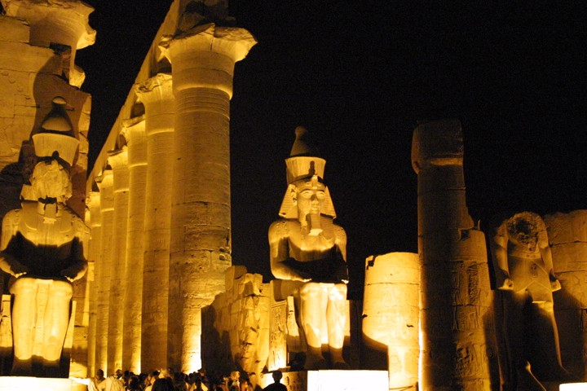

A preferred point to start the Nile Cruise and also the only point for the start of the 4 night cruise.
One visits the Valley of the Kings here – this is the area where there are several hillocks that hide the tombs of the bygone pharos. They are all well camouflaged so that they remained hidden from the eyes of the prying dacoits. Inspite of that, all the tombs have been raided and all the wealth gone. Since the place is naturally well protected by the hills on all sides, any mobile network is not available here.
Next stop is the Tomb of Hatshepsut. She was the only queen to rule Egypt, and the only lady to have a tomb dedicated to her in the Valley of the Kings. This denotes how powerful she was. It’s a very huge grand structure.
Luxor is also famous for the Karnak Temple. This is a magnificent structure and the entrance is grand. There are several demigods adorning the same. One can also opt for and enjoy the Sound and Light show here like the one at the Giza Pyramids.
Enter from the corniche or Sharia el-Karnak. Open: 06h00-17h30 (October-April); 06h00-18h30 (May-September).
Light and Sound Show: English tours take place on Monday, Thursday, Friday at 20h00; Saturday, Sunday, Tuesday, Wednesday at 21h15
Lastly one can also find the Colossi of Memon statues here. These are the only remains of the once grand Temple that stood here.
The other places that one passes during the cruise are: Kom Ombo where again one gets to see some great architectural wonders.
Edfu where you can see the Temple of Horus and Esna where you cross the lock.

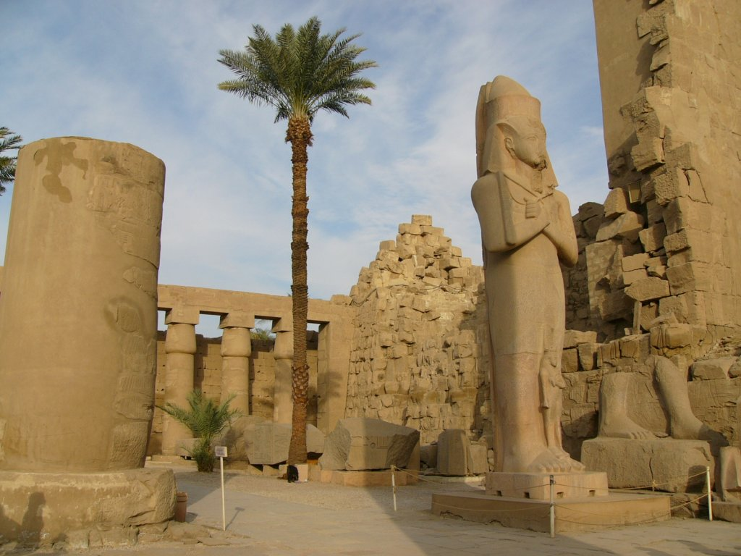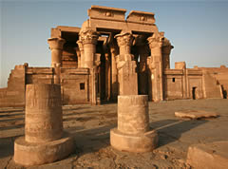

ASWAN

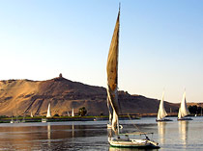

Aswan, Egypt's southernmost city has long been the country's gateway to Africa. The Nile is glorious here as it makes its way down from the massive High Dam and Lake Nasser - watching the feluccas (traditional sail boats) glide by as the sun sets over the Nile is an experience you're unlikely to forget. A visit to the Tombs of the Nobles is worthwhile, a highlight being the Nubian Museum.
It’s recommended for one to take the felucca and sail to the Temple of Philae which is located on an island

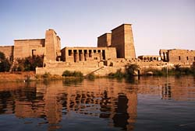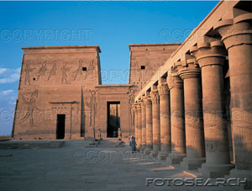

ABU SIMBEL

Abu Simbel lies near the Egyptian border with Sudan. The closest major town is Aswan. You can get to Abu Simbel by air (45mins flight) from either Cairo or Aswan. There are also daily buses and tours from Aswan to Abu Simbel (3.5hrs drive).
The largest and most spectacular temples, built by King Ramses II dedicated to the sun god, Ra, the second one built in honour of his favourite wife, Nefertari. The main temple is 33 meters high and 35 meters wide and guarded by four colossal statues of the king, each some 20 meters high.
The mammoth temples built for the Pharaoh Ramesses II, had to be dismantled and physically moved 60 meters up a cliff where they were reassembled in the exact same relation to each other and the sun so that they don’t get submerged under the Lake Nasser. Natural sunlight and architectural brilliance combine to make the inner sanctum of the temple light up.

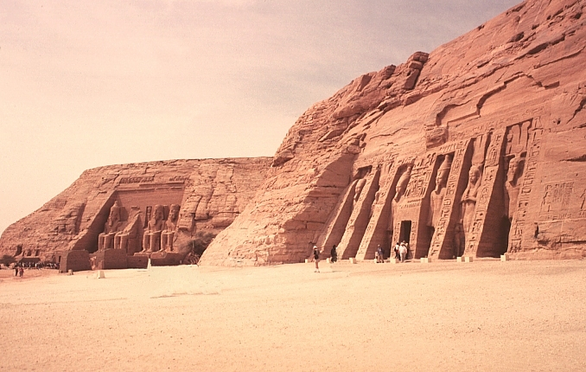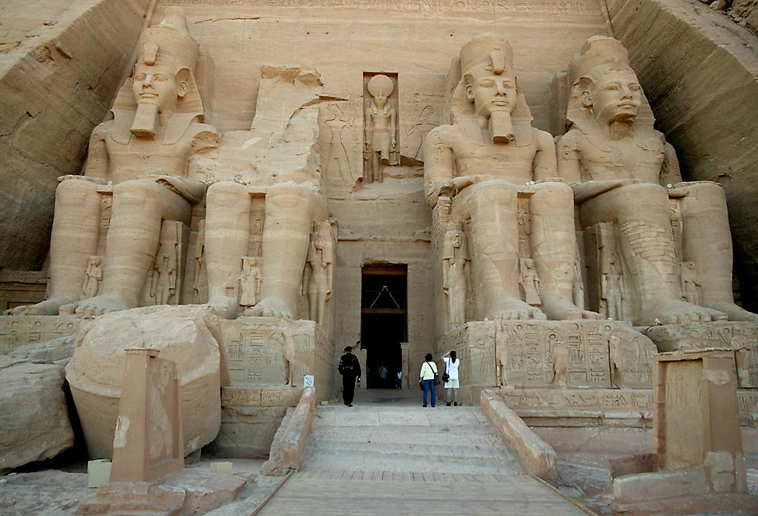

HURGHADA
Egypt's top destinations for those looking to simply relax on the beach or enjoy some of the world's clearest waters and spectacular coral reefs. Hurghada offers more than 10 miles of beach and plenty of accommodation, restaurants and nightclubs for all budgets. Diving is the most popular attraction here and there are numerous diving centers and schools around town. You can expect to see hundreds of spectacular fish both along the shore and around the nearby islands. For a dash of color there's: the blue-spotted stingray, lionfish, Hurghada Star and the Spanish Dancer Nudibranch
The easiest way to reach here is to take the cruise from Aswan to Luxor and hook up with the convoy that leaves daily from Luxor to Hurghada. The drive is by road along the sandy dunes and desert and takes approx 3 hours.
Hurghada is renowned for having the best nightlife on the Red Sea coast. It’s recommended to spend a min of at least 2 nights here and one can then fly back to Cairo.
There are several hotels available here and again the 5 star chains are the ones that are recommended.
Clothes are abundant here and quite affordable.

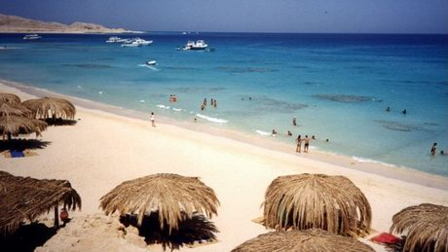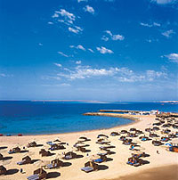

Recommended Hotels in Hurghada:
Hilton Hurghada Plaza
Holiday Inn Hurghada
Marriott Hurghada
Swiss Inn Royal Azur Resort

SHARM EL SHEIKH

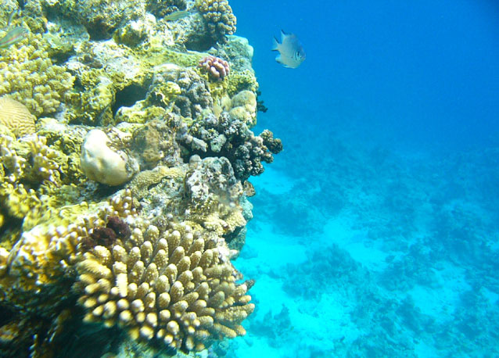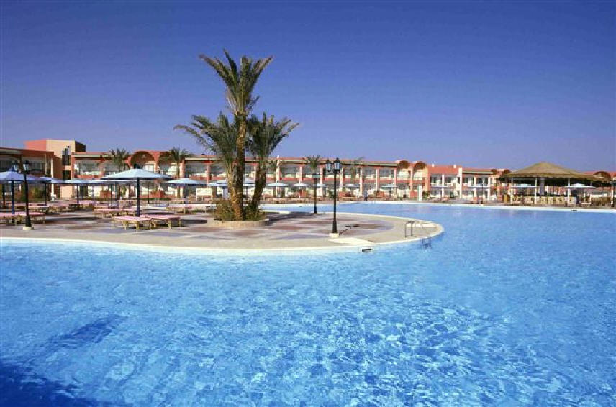

Located in the Sinai Peninsula this is a place that is truly located by the Red Sea. It is jocularly referred to as the rich cousin of Hurghada. One can reach here by flight from any of the cities (Cairo / Luxor / Aswan / Hurghada). There are some exotic Resorts here and this place is often referred to as the Mecca for divers.
One of the most beautiful and famous deep-sea diving paradises in the world. Your dreams of crystal clear water, magnificent corals, exotic under water flora and rare tropical fish all come true when you visit Sharm El Sheikh on the Southern tip of the Sinai Peninsula. It is also noted for its sulphur springs, which are considered cures for those suffering from rheumatic and skin diseases.
Sharm is very cosmopolitan with an array of exceptional bays, a concentration of luxurious hotels, restaurants, golf courses, conference facilities, banks, nightlife, shopping facilities, and above all, unprecedented coral reefs and marine life.
Extremely popular are the national marine parks along the coastline. Just 25 kilometres southwest of Sharm, Ras Mohammed is Egypt’s most frequented protected national park, especially noted for being an underwater paradise. Established in 1983 and spanning across 480 square kilometres, it is the country’s first and largest national Marine Park.
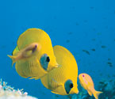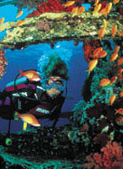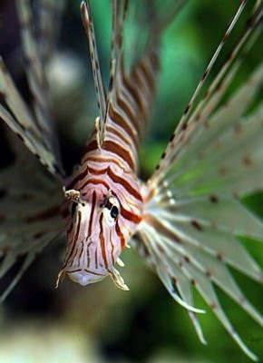

Ras Mohammed is also known for its Tiran and Sanafir islands, salt marshes, sea-grass beds, mountain peaks and mangrove trees. Winter season brings in a variety of migrating birds including the white stork Ciconia. Many endangered underwater species live in the deep waters including the Hawksbill Turtle and Green Turtle; while terrestrial wildlife animals such as the Dorcas Gazelle and Nubian Ibex can also be found in Ras Mohammed.
Sinai Desert which provides a wonderful opportunity to ride a camel and see the dunes, climb up Mount Sinai and visit St Catherine's Monastery.
Located at the foot of Mount Sinai and St. Catherine Mountain, St Catherine’s Monastery is probably the first and smallest Christian monastery in the world. St. Catherine’s Monastery has been declared as one of the most important sights in the world.

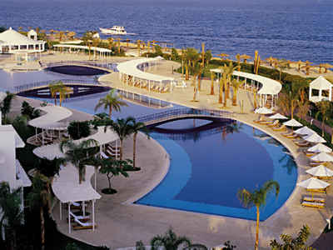

Hotels in Sharm El Sheikh:
Hyatt Regency Sharm-El-Sheikh
Ritz Carlton Sharm-El-Sheikh
Movenpick Hotel Sharm-El-Sheikh
Sofitel Hotel Sharm-El-Sheikh
Marriott Hotel Sharm-El-Sheikh

ALEXANDRIA

The second largest city in Egypt, Alexandria, known as "The Pearl of the Mediterranean", has an atmosphere that is more Mediterranean than Middle Eastern; its ambience and cultural heritage distance it from the rest of the country although it is actually only 225 km. from Cairo. So one can stay for night or even a day trip is possible.
A city that is completely overpowered by Greco Roman architecture, it is a mere 3 hrs drive from Cairo.
One can visit here either as a Full day trip or even decide to spend a night here. One can see the influence of complete Roman Architecture here in the Pompeii’s pillar – a colossal granite pillar. The Catacombs of kom el – shokafa are awe inspiring. Visit the Montazah Palace – the summer residence of egypt’s former royal family, it was built on an elevator that overlooks one of the most attractive beaches of Alexandria. The palace comprises a number of buildings, the most important is the “salamlek” whose 1st floor was converted into an international casino & its 2nd and 3rd floor into a museum that display private belongings of the former royal family.
Being so close to the Mediterranean Sea the climate is quite salubrious and warm.
Alexandria is a great place to just relax and soak in the Egyptian atmosphere. It doesn't have quite the bustle of Cairo and there aren't too many major sights you feel you have to see. The cafes by the waterfront are excellent places to just relax, enjoy a traditional coffee and watch the world go by.

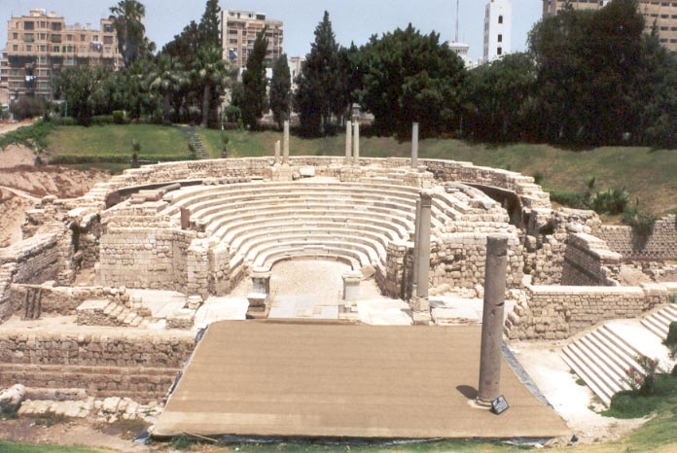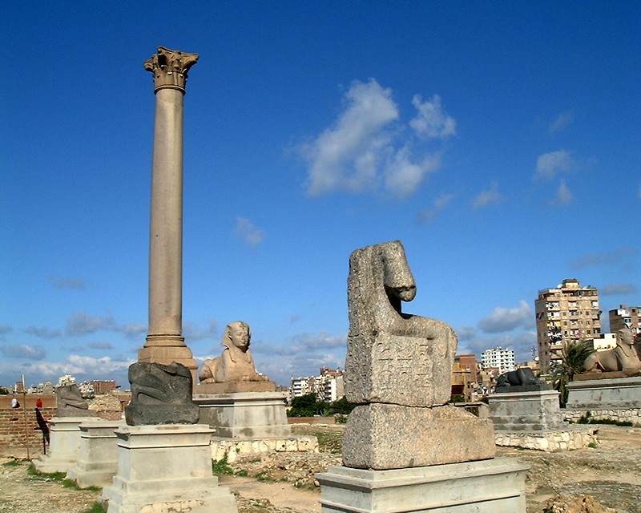

OASES

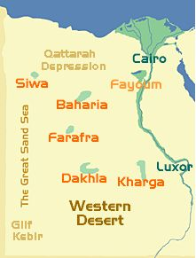

Egypt's oases are just refuges from the modern world, in the dramatic setting of the desert surrounded by sand and sky, the oases have a sense of timelessness
The Western Desert has six main oases, one close to Libya, four in a curved row from Cairo to Luxor and the last south of Cairo.

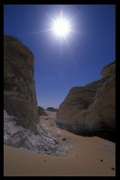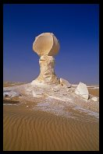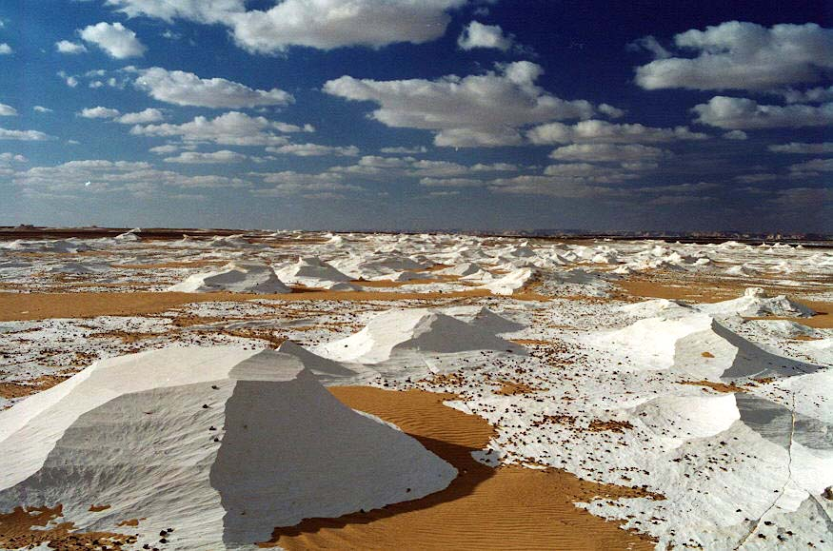

Fayoum Oasis
Its possible (and highly recommended) to visit Fayoum Oasis on a full day tour from Cairo.

Kharga Oasis
Kharga is the administrative centre for the oases in Wadi Gedid (Baharia, Farafra, Dakhla and Kharga) and hasancient Egyptian temples, important early Christian history and a small but important museum with a collection from Pharaonic times, Christian and Islamic area.

Dakhla Oasis
Dakhla is the largest agriculture oasis and lies furthest off the main settlements of Egypt. Unlike many other oases, it is situated above sea level, as high as 122 meters. Still it is fed by more than 520 springs and ponds. The main towns are Mut and Al-Qasr, the latter the main attraction in the entire oasis. The Muzawaka tombs and Deir al-Hagar temple are the main attractions.

Farafra Oasis
Farafra is a smaller oasis, and the most important here is the unbelievable White Desert.
It is a vast stretch of land in the Western Desert that borders Bahariya Oasis to the north and Al-Farafra to the south.The snow-white desert is actually made of chalk that has been exposed for years to what geologists call "differential weathering," the erosion of soft particles that results in eerie protrusions of hard rock. This explains the very beautiful forms that now fill the White Desert including shapes like domes, minarets, castles, towers and so forth.
The destination has proved a great attraction to all travelers who camp in the few oases, watch the fauna and flora and enjoy the mild winter weather. Shallow water levels allow for modest vegetation and wildlife.

Baharia Oasis
Baharia is the northern oasis of these four, and here you will find one of the hot springs - inside the small hotel. Siwa Oasis got its own history unlike the four mentioned, and here one the two important oracles of the antique world was located.
Bahariya Oasis is easy to reach from Cairo, about 365 kilometres south-west of Cairo and it is the best starting point for the Black and White Desert. Set in a depression covering over 2000 sq. km. Bahariya Oasis is surrounded by black hills made up of ferruginous quartzite and dolorite. The oasis is provided with water by many springs. The most famous of these, a thermal spring with medicinal and restorative properties, comes out in the Bedouin village of Bawiti. Wildlife is plentiful; especially birds such as wheatears, Bahariya Oasis might also appeal rock hounds. Golden Mummies were discovered - 'Valley of the Mummies' is the biggest of its kind. The mummies are covered with a thin layer of gold and wearing gypsum masks. Sumptuous gilded death masks depict lifelike faces of real people, rather than stereotypical images. They were found in four tombs in the town of Bawiti in Bahariya Oasis.

Siwa Oasis
Siwa appears at first as a sweet and innocent place deep in the desert which has just opened its eyes to the modern world and still let's itself be amazed. Which is not wrong, the asphalted road opened first in 1984. is also one of the most fascinating, lying some 60 feed below sea level. On the edge of the Great Sand Sea, its rich history includes a visit from Alexander the Great to consult the Oracle of Amun in 331 BC. The area has a nice climate, chilly in winter, hot in the summer and moderate in the spring and autumn. Lake Siwa to the west of the town of is a large, saltwater lake.
The area is also famous for its springs, of which there are approximately 1,000. The water is sweet, and is said to have medical properties.

An itinerary with the Egyptian Oases can be of ideally 10 days including of about 2nts in Cairo, 4nts in the different Oases, 2nts in Luxor and 2nts in Hurghada. It is usually an all inclusive package with all meals included. All the Transfers are arranged from Cairo on private Jeep 4x4 Toyota Land cruiser.

FOOD:
In Egypt, dining out can range from stand-up sandwich bars to luxurious five-course meals
The food is usually very good in the hotels; however, stick with fruit and vegetables which can be peeled, if they were not cooked. Bring some crackers, nuts, and other snacks for the long tours. Soft drinks & water are no problem on the tours because there is always somewhere some “Coca-Cola temple” tea bags and some instant coffee, together with your water boiler are also very helpful in your hotel room. The typical tea available is called the “karkade” and is made from the karkade flower. It is pink in color and the dried petals are used to make the tea. The same has medicinal value and is drunk either hot or cold. Its great for balancing the blood pressure. One can buy the petals at the local markets by the kilo.

Indian Restaurants in Cairo:

Biryani
Add: Mohamed Kamal Morsi St., Off El-Battal Ahmed Adel Aziz St., Mohandeseen, Cairo
Tel: 002 02 760 94 30 / 760 63 53

Bukhara
Add: 43 Misr Helwan Road, Maadi, Cairo
Tel : 002 02 380 5 999

Kandahar
Add: 3, Gameat Al-Dowal Al-Arabia St., Sphinx. Sq
Te: 002 02 30 30 615

Tandory
Add: 11 Shehab St., Mohandeseen, Cairo
Tel: 002 02 748 63 01

Indian Restaurant In Luxor:

Agra at Sheraton Luxor Hotel
Tel : 002 095 2 374 597 / 374 544
Fax: 002 095 2 371 941

Indian Restaurant In Aswan:

At Elephantine Hotel Aswan
Tel: 002 097 2 314 667 / 666
Fax: 002 097 2 31 35 38

Indian restaurants in Sharm El Shaikh:
Rangoli
Sofitel Hotel, Na'ama Bay
Tel: +20 (0)69-360-0081

Tandoori
Camel Dive Club & Hotel, Centre of Na'ama Bay
Tel: +20 (0)69-360-0700

SHOPPING and MUST BUYS:
The most famous market here in Cairo is the Khan El Khalili Market and is open normally from 1000 hrs until 2100 hrs daily. The market is extremely crowded and hence it is recommended that one gets dropped here and later make your own way back to the hotel. One can find just about everything here, from the quaint antiques to camel leather seats, to precious stones and to the more popular spices, dry fruits and the karkade petals. This is also a good place to get the best rate for your Dollar, though of course they are unauthorized dealers selling the same to you. Pls remember that there is no guarantee for the authenticity of the currency being given to you. It’s a chance.
One also must bring back Papyrus paintings of Nefretti or the Scarab (the bug, which is a lucky charm). Semi precious stones of onyx, etc and Attar are very typical. Silver is quite famous here too and pendants signifying the key of life are quite nice to present and keep.
Vases of Alabaster are typically found in Luxor but can be found in the Khalili market as well.
There are several shops in Cairo that sell Leather goods. The shoes and boots particularly are very affordable and sturdy.
Surprisingly the Egyptian cotton garments that are so famous worldwide are not readily available in Egypt itself!
Coppersmiths' Bazaar (Souk el-Nahhasin) within the Khan complex for finely crafted brass and copperware. A thousand years of craftsmanship goes into items as diverse as candlesticks, coffee sets, trays, gongs and water pipes. Head for the Khan's Goldsmiths' Bazaar area (Souk es-Sagha) for gold and silver jewellery.
All gold work is stamped with Arabic numerals indicating its purity. Popular purchases include gold cartouches with the person's name in hieroglyphics. Ceramics and glass items are also good buys.
Travelers are free to buy and export Egyptian goods. There are restrictions on certain items that are not permitted to leave the country. Under no circumstances are antiquities, either ancient Egyptian or Islamic, permitted to be exported. Nor are precious jewels, carpets, paintings or other works older than 100 years

Khan el-Khalili is the biggest and the best example, with several different areas all selling various produce, but literally dozens of smaller markets crowd Cairo's streets. Try some of the other famous street markets, like Wekala al-Balaq, for fabrics, including woven Egyptian cotton, the Tentmakers' Bazaar for appliqué work, and Mohammed Ali Street for musical instruments.

